31 August 2012

NOTICE OF COMPANY CONVERSION

This serves to inform you that Trade and Investment KZN (1998/011946/08), a company that was incorporated under Section 21 of the Companies Act of 1973 has been converted, as a going concern, into a Provincial Public Entity (Schedule 3C) in terms of the KwaZulu-Natal Trade and Investment Act of 2010.

As a result of this conversion, all contractual obligations with the former organization have been transferred to the new entity, regulated by the Public Finance Management Act (PMFA).

Should you have any questions in this regard, please contact Ms Lingiwe Nyamande on (031) 368-9606 or lingiwe@tikzn.co.za

Yours faithfully
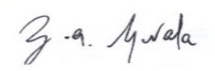
___________________________
Zamo Gwala
Chief Executive Officer

